

MATCHING SPs AND TABLES

#### Document History

|  |  |  |  |  |  |
| --- | --- | --- | --- | --- | --- |
| Date | Version | Revision Details | Author | Reviewed By | Approved By |
| 18 Sep 2015 | 1.0 | Matching SPs and Tables | Ajith PA | Mahesh KM |  |
|  |  |  |  |  |  |

#### Table of Contents

|  |  |  |
| --- | --- | --- |
| Sl No | Section | Page No |
| 1 | Matching | 4 |
|  |  |  |

## Matching

Below tables and stored procedures are used in matching component.

|  |  |  |
| --- | --- | --- |
| **Sl.No.** | **Name** | **Type** |
| 1 | Questionnaire | Table |
| 2 | QuestionnaireAnswers | Table |
| 3 | QuestionnaireCategoryCW | Table |
| 4 | QuestionnaireCategory | Table |
| 5 | Module_Actions | Table |
| 6 | User_Module_Permissions | Table |
| 7 | Child_Profile_Approval | Table |
| 8 | Questionnaire_Weightage_Labels | Table |
| 9 | USP_ListParentApplInfo | StoredProcedure |
| 10 | USP_GetQuestionnaireAnswers | StoredProcedure |
| 11 | USP_GetMatchPercentage | StoredProcedure |
| 12 | USP_SaveParentApplInfo | StoredProcedure |
| 13 | USP_MatchSystem_GetChildList | StoredProcedure |
| 14 | USP_GetMatchPercentage_SDC | StoredProcedure |
| 15 | USP_CalculateMatchingScore | StoredProcedure |
| 16 | USP_SaveQuestionnaireAnswers | StoredProcedure |
| 17 | USP_Edit_QuestionnaireCategoryCW | StoredProcedure |
| 18 | USP_GetMatchedList | StoredProcedure |
| 19 | USP_ListChildInHome | StoredProcedure |
| 20 | UDF_CaseWorkerListBrk | Function |

**Questionnaire:**

It is used to save all matching questionnaire for adoptive parent and child.

|  |  |  |  |
| --- | --- | --- | --- |
| **Column name** | **Type** | **Length** |  |
| ID | int | 4 | |  | | --- | |  | | |
| CategoryID | int | 4 |
| Question | nvarchar | -1 |
| AnswerType | int | 4 |
| LookUpTable | varchar | 250 |
| seq | int | 4 |
| ShowToApplicant | bit | 1 |
| ShowToChild | bit | 1 |
| weightage | decimal | 5 |
| MatchingQuestionId | int | 4 |
| NoOfOptions | int | 4 |
| IsScalable | bit | 1 |
| Range1 | decimal | 9 |
| Range2 | decimal | 9 |

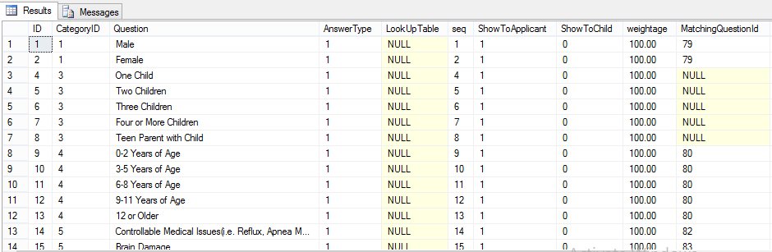

**QuestionnaireAnswers:**

It is used to save answers against each question submitted by adoptive parent and child.

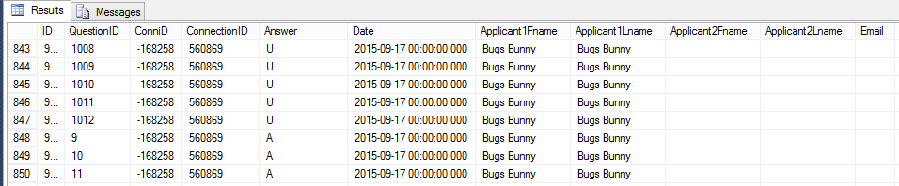

|  |  |  |  |
| --- | --- | --- | --- |
| **Column Name** | **Type** | **Length** |  |
| ID | int | 4 | |  | | --- | |  | | |
| QuestionID | int | 4 |
| ConniD | int | 4 |
| ConnectionID | int | 4 |
| Answer | nvarchar | -1 |
| Date | datetime | 8 |
| Applicant1Fname | varchar | 100 |
| Applicant1Lname | varchar | 100 |
| Applicant2Fname | varchar | 100 |
| Applicant2Lname | varchar | 100 |
| Email | varchar | 100 |
| weightage | decimal | 5 |
| IsChanged | bit | 1 |
| IsSkipped | bit | 1 |
| CatWeightage | decimal | 9 |
| Exclude | bit | 1 |

**QuestionnaireCategoryCW:**

|  |  |  |  |
| --- | --- | --- | --- |
| **Column_name** | **Type** | **Length** |  |
| ID | int | 4 | |  | | --- | |  | | |
| Category | varchar | -1 |
| CategoryType | int | 4 |
| Seq | int | 4 |
| Weightage | decimal | 9 |
| ShowToApplicant | bit | 1 |
| ShowToChild | bit | 1 |
| CaseworkerId | int | 4 |
| CreatedBy | int | 4 |
| CreatedDate | datetime | 8 |
| ModifiedBy | int | 4 |
| ModifiedDate | datetime | 8 |

**QuestionnaireCategory:**

It is used to store different question categories for adoptive parent and child.

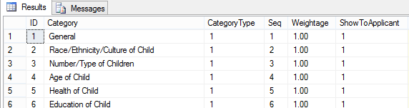

|  |  |  |  |
| --- | --- | --- | --- |
| **Column_name** | **Type** | **Length** |  |
| ID | int | 4 | |  | | --- | |  | | |
| Category | varchar | -1 |
| CategoryType | int | 4 |
| Seq | int | 4 |
| Weightage | decimal | 9 |
| ShowToApplicant | bit | 1 |
| ShowToChild | bit | 1 |

**module_actions:**

It is master table for caseworker permission.

|  |  |  |  |
| --- | --- | --- | --- |
| **Column_name** | **Type** | **Length** |  |
| id | int | 4 | |  | | --- | |  | | |
| parent_id | int | 4 |
| action_name | varchar | 255 |
| delete_flag | bit | 1 |

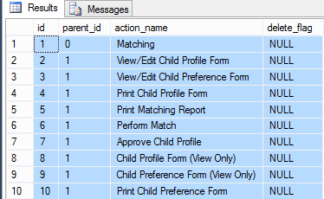

**User_Module_Permissions:**

This table is used to save user permission.

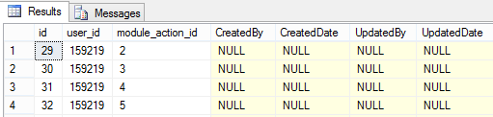

|  |  |  |  |  |
| --- | --- | --- | --- | --- |
| **Column_name** | **Type** | **Length** |  | |
| id | int | 4 | |  | | --- | |  | | | |
| user_id | int | 4 |
| module_action_id | int | 4 |
| CreatedBy | int | 4 |
| CreatedDate | datetime | 8 |
| UpdatedBy | int | 4 |
|  | | | |

**Child_Profile_Approval:** Approved child’s profiles are saved in this table

|  |  |  |  |
| --- | --- | --- | --- |
| **Column_name** | **Type** | **Length** |  |
| approve_id | int | 4 | |  | | --- | |  | | |
| user_id | int | 4 |
| ConnId | int | 4 |
| reviewed_by | int | 4 |
| approved_by | int | 4 |
| approved_date | datetime | 8 |

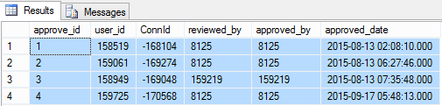

**Questionnaire_Weightage_Labels:**

|  |  |  |  |
| --- | --- | --- | --- |
| **Column_name** | **Type** | **Length** |  |
| id | int | 4 | |  | | --- | |  | | |
| question_id | int | 4 |
| radio_label1 | varchar | 255 |
| radio_label2 | varchar | 255 |
| radio_label3 | varchar | 255 |
| radio_label4 | varchar | 255 |
| radio_label5 | varchar | 255 |
| createdBy | int | 4 |
| created_date | datetime | 8 |

**USP_ListParentApplInfo:**

Which is used to display all parent information. It is only for SDC.

|  |  |  |  |
| --- | --- | --- | --- |
| Parameter_name | Type | Length |  |
| @AP1ConnId | int | 4 |  |
| @AP1ConnectionID | int | 4 |
| @AP2ConnId | int | 4 |
| @AP2ConnectionId | int | 4 |

**USP_GetQuestionnaireAnswers:**

This procedure is used to display all questions and answers against a child or adoptive parent.

|  |  |  |  |
| --- | --- | --- | --- |
| **Parameter_name** | **Type** | **Length** |  |
| @Connid | int | 4 |  |
| @Connectionid | int | 4 |
| @ShowToApplicant | bit | 1 |
| @ShowToChild | bit | 1 |
| @CaseworkerId | int | 4 |

**USP_GetMatchPercentage:**

Which is used to find out the matched child’s for an adoptive parent. Records are listed based on the rank. USP_CalculateMatchingScore this procedure is called inside this procedure.

|  |  |  |  |
| --- | --- | --- | --- |
| **Parameter_name** | **Type** | **Length** |  |
| @ConnId | int | 4 |  |
| @ConnectionId | int | 4 |
| @MatchProfileNo | int | 4 |
| @CWID | int | 4 |

**USP_SaveParentApplInfo:**

It is used to save applicant information from matching component.it is used only for SDC.

|  |  |  |  |
| --- | --- | --- | --- |
| **Parameter_name** | **Type** | **Length** |  |
| @UserID | int | 4 |  |
| @AP1ConniD | int | 4 |
| @AP1ConnectionID | int | 4 |
| @AP2ConniD | int | 4 |
| @AP2ConnectionID | int | 4 |
| @APSocialWorker | varchar | 100 |
| @SWPhone | varchar | 20 |
| @ApprovalDate | datetime | 8 |
| @RevisionDate | datetime | 8 |
| @FamilyName | varchar | 250 |
| @Add1 | varchar | 250 |
| @Add2 | varchar | 250 |
| @AP2Add1 | varchar | 250 |
| @AP2Add2 | varchar | 250 |
| @City | varchar | 200 |
| @AP2City | varchar | 200 |
| @State | int | 4 |
| @AP2State | int | 4 |
| @Zip | varchar | 50 |
| @AP2Zip | varchar | 50 |
| @Country | int | 4 |
| @AP2Country | int | 4 |
| @County | varchar | -1 |
| @AP2County | varchar | -1 |
| @HomePhone | varchar | 20 |
| @AP2HomePhone | varchar | 20 |
| @LengthOfMarriage | varchar | 100 |
| @ReturningToWork | varchar | -1 |
| @AP2ReturningToWork | varchar | -1 |
| @AtHomeParent | varchar | -1 |
| @AP2AtHomeParent | varchar | -1 |
| @LengthOfLeave | varchar | -1 |
| @AP2LengthOfLeave | varchar | -1 |
| @Extension | varchar | 10 |
| @AP2Extension | varchar | 10 |
| @TypeOfPets | varchar | -1 |
| @AP1Name | varchar | 100 |
| @AP1DOB | datetime | 8 |
| @AP1Degree | varchar | 100 |
| @AP1Occupation | varchar | 100 |
| @AP1Religion | varchar | 100 |
| @AP2Name | varchar | 100 |
| @AP2DOB | datetime | 8 |
| @AP2Degree | varchar | 100 |
| @AP2Occupation | varchar | 100 |
| @AP2Religion | varchar | 100 |
| @ASL | varchar | 10 |
| @AP2ASL | varchar | 10 |
| @Smoker | varchar | 10 |
| @AP2Smoker | varchar | 10 |
| @TypeOfPlacement | varchar | 100 |
| @AP1Ethnicity | xml | -1 |
| @AP1Language | xml | -1 |
| @AP2Ethnicity | xml | -1 |
| @AP2Language | xml | -1 |

**USP_MatchSystem_GetChildList:**

It is used to list all active children in the system for matching.

|  |  |  |  |
| --- | --- | --- | --- |
| **Parameter_name** | **Type** | **Length** |  |
| @ChildName | varchar | -1 |  |
| @HasInfo | char | 1 |
| @StRow | int | 4 |
| @EndRow | int | 4 |
| @FirstName | varchar | -1 |
| @LastName | varchar | -1 |
| @BirthFirstName | varchar | -1 |
| @BirthLastName | varchar | -1 |
| @NickName | varchar | -1 |
| @SSN | varchar | -1 |
| @DOB | datetime | 8 |
| @Rellabel | varchar | 250 |

**USP_CalculateMatchingScore:**

This procedure is used to calculate matching score with respect to adoptive parent and child. Which is called inside USP_GetMatchPercentage procedure.

|  |  |  |  |
| --- | --- | --- | --- |
| **Parameter_name** | **Type** | **Length** |  |
| @ConnID | int | 4 |  |
| @ConnectionId | int | 4 |
| @MchConnID | int | 4 |
| @MchConnectionID | int | 4 |
| @ExecAll | bit | 1 |
| @ExecMatchAll | bit | 1 |
| @CWId | int | 4 |

**USP_SaveQuestionnaireAnswers:**

Which is used to save question answers for matching submitted by child or adoptive parent. Input should be in xml datatype.

|  |  |  |  |
| --- | --- | --- | --- |
| **Parameter_name** | **Type** | **Length** |  |
| @formdata | xml | -1 |  |

**USP_Edit_QuestionnaireCategoryCW:**

Using this stored procedure caseworker can edit category weightage

|  |  |  |  |
| --- | --- | --- | --- |
| **Parameter_name** | **Type** | **Length** |  |
| @CaseworkerId | int | 4 |  |
| @xmlData | xml | -1 |